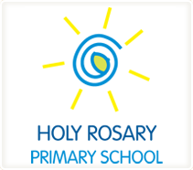

The pupils and staff of Holy Rosary Primary School would like to invite you to come in to visit our school
on Thursday 1st February 2018 at 11.00am.

Enjoy performances from various classes in the school and the school choir followed by a visit to your grandchild’s classroom and finished off with a cup of tea or coffee and some sweet treats.

We look forward to seeing you then.

