Children’s Books About Death and Dying

An important but difficult thing to discuss with children is the subject of death. Listed below are some good books which can give you help.
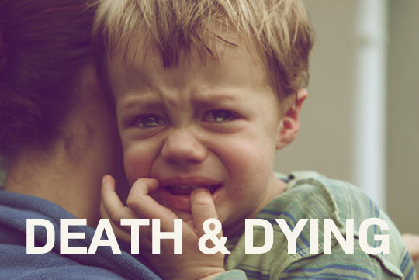

Top 5 Children’s Books About Death and Dying
The Next Place: This is a great child’s book for children who are dealing with someone who is dying because of an illness. It’s an inspirational story about hope and light where hurts on earth are no longer there. Although it’s written for children, many different adults have found it to be inspirational and helpful in their own time of grief. It helps to show the reader that even though the person who died was sick and hurting before they died, they are no longer in pain and they are whole now.

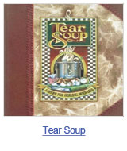 | Tear Soup: Even though this is in the list of children’s books about death, this book is excellent for adults too. It’s about a woman who has suffered some kind of loss and makes something known as tear soup. The soup blends different unique ingredients of the life she lived within the process of her grieving. She also gives some sound advice for the people who are mourning or who know another person that is in mourning. It’s a beautifully illustrated book that parents and children will enjoy, and perfect for anyone who has lost a loved one. It illustrates that everyone grieves in a different way.

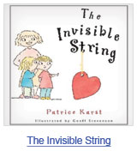 | The Invisible String: The Invisible String is a children’s story that talks about an invisible string which connects people to their loved ones. When someone thinks of another person, there is a tug on the string that is felt. This book is not just for those who have lost others to death. In fact, a lot of families use it when someone has been deployed overseas. It just goes to show that the people that we are missing aren’t really gone as long as we remember them and talk about them. This story is a great read for anyone that is missing someone, either from death or from them being away, and realizing that they are not really gone.

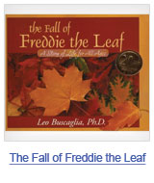 | The Fall of Freddie the Leaf: Although this story is very simple, it tells a wonderful story about Freddie and the other leaves as they go through the different seasons and finally fall to the ground. Many people associate the fall and winter with death, and that is why this book is so appropriate. It illustrates the balance that is found between death and life, and is great for adults and children alike.

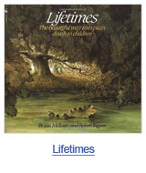 | Lifetimes: When you are searching for a wonderful book to explain death to a child, Lifetimes is one that you can turn to. Whether the death is of a friend, a family member, this book is a useful tool for parents to help broach the subject of death. This book is also regularly suggested to adults who are dealing with the loss of someone. Many people read this to their children even though they are not in the time of grieving because parents want to show them that death is a normal part of life.

Other Great Books on Death
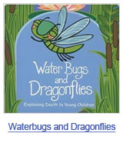 | Waterbugs and Dragonflies: This child’s book uses metamorphosis to explain death to children. It talks about how people who have died can’t come back to talk to us but that they are waiting for us in a better place.

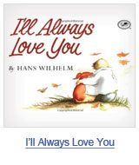 | I’ll Always Love You: Within this soft and moving tale called I’ll Always Love You, Elfie who is dachshund, along with her very special boy advance contentedly through their life with each other. When she’s younger, Elfie is filled with pep as well as pranks; however while her master grows up, Elfie becomes heavier as well as slower. One particular morning Elfie doesn’t awaken. The whole family grieves along with buries Elfie, and also the boy declines a brand new puppy. He isn’t yet ready to get a new pet; however when he is, he’ll say to that pet, since he told Elsie each night, “I’ll always love you.” The watercolor pictures, soft and comfortable in both mood and color and cozily curved in their form, match the basic wording flawlessly.

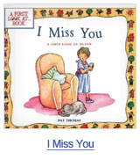 | I Miss You: A First Look at Death: A First Look at Death: Whenever a good friend or member of the family passes away, it can be hard for youngsters to convey their particular emotions. I Miss You: A First Look at Death will help girls and boys realize that dying is really a natural balance to life, and also that sadness along with a a feeling of loss are common emotions for child to have after a cherished one’s death.

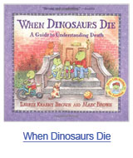 | When Dinosaurs Die: Compared with a lot of children’s books on death, this book won’t tell a tale. Rather, it deals with children’s worries and fascination head-on, plus in a mostly secular style, through responding to a few standard questions. Alternative questions address feelings, and there is a portion regarding death traditions This forthright method helps make the topic appear much less unfamiliar and supplies youngsters with a lot to consider as well as speak about with their mother and father.

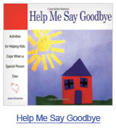 | Help Me Say Goodbye: Setting it apart from the other children’s books about death is the way that Help Me Say Goodbye helps kids to deal with death. Instead of a story to read, this book is full of activities that can help children to understand death and to use pictures to express how they are feeling. The exercises that are in the book will help the children with the ways that they are feeling.

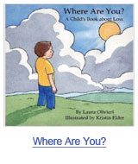 | Where Are You?: This is a child’s book that was written by a woman who lost her husband when her son was only 3. It’s a supportive and kind text that is beautifully illustrated. It?s made to help children that are of all different ages to deal with losing someone that they loved. This is a story about a boy whose father died. He deals with the absence of his dad and the realization that he’s always going to be close to his dad. The way that it’s created makes it good for even the very youngest children who are going to find comfort within its pages.

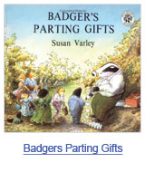 | Badgers Parting Gifts: In the book Badger’s Parting Gifts , when Badger dies, his friends feel very sad that he is no longer with them. The memories of Badger’s gifts that he shared with them help them to gain strength. They find themselves facing the future full of hope. This is an excellent book for parents to share with their children. It’s written for children but a lot of adults have found that they find some peace and comfort in their sadness.

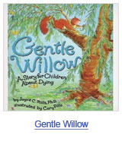 | Gentle Willow: Written for the children who might not make it through their sickness or even for the youngsters that know those children, Gentle Willow, a sensitive and emotional tale, will help handle feelings of shock, rage, and depression. It’s combined with love as well as sympathy. Little Tree and Amanda find out that their good friend Gentle Willow just isn’t feeling very well. Amanda brings beings known as Tree Wizards. They go to see Gentle Willow and find out they are unable to make her feel better. Amanda is quite upset to begin with, but gradually she listens as the Tree Wizards express that dying is really a change as well as a trip to the unfamiliar. Additionally they advise Amanda the medication she could provide Gentle Willow will be love. Within a last act of affection, Amanda ends up comforting Gentle Willow, who’s scared, using a tale concerning the caterpillar which changes right into a butterfly. This is a beautiful tale of friendship and helping friends to get through an illness in their life. It also shows that you shouldn?t be scared when a friend is sick. That’s when they need you the most.

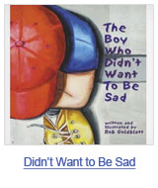 | The Boy Who Didn’t Want to Be Sad: This is the tale of the boy that was sad and didn’t wish to be sad any longer. Therefore, he created a good plan. The plan would be to do away with whatever made him to be sad. He systematically takes out items as soon as he recognizes they’re making him sad as well as have the possibility to help make him sad. In the end he understands that doing away with all that might make him sad additionally completely got rid of all that helped him be happy. A lot of children believe that it’s wrong to be sad so they often hold their feelings in. but this book shows that sadness is a part of life. It is a lesson regarding dealing with sadness to ensure that we are able to additionally live a happy as well as fulfilled life.

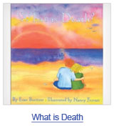 | What is Death: What is Death addresses many different questions that children might have about the subject of death. It has the different beliefs and customs that are from various cultures and religions, and lets the reader to think about identity, tolerance, and generosity. It’s based in reality and uses a tone that is gentle as well as comforting.

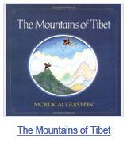 | The Mountains of Tibet: This tale about the death as well as reincarnation of a Tibetan woodcutter is truly a amazingly gentle view of a single individual coping with life’s options and opportunities. When he was a boy, he contemplated the various other worlds he would one day explore; in the form of man, he considered various other nations and individuals, but he was constanytly too busy. Following his passing away, he’s provided with the choice of going to ‘Heaven’ or having yet another life. He selects an additional life. The options that follow all take him throughout every one of the universes, stars, creatures, planets, peoples, parents, and countries, before coming to the last twist within this trip. This is a different story than other children’s books about death and explores other dimensions of death.

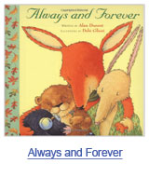 | Always and Forever: In Always and Forever, four animal friends live together in their woodland house. When one of them dies, the other three are struggling with grief. But when the remember the wisdom, support, and love that their friend showed them as well as the funny things he did, they make a memorial for their friend. When the garden is done and they’re sitting there, they realize that he’s still with them in their laughter and memories. The book tells a tale without rushing through the grief stages.

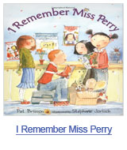 | I Remember Miss Perry: Most children have a favorite teacher that they love and will always remember. This story deals with children losing a favorite teacher. This teacher made every day special and had fondest wishes for each and every day. The story helps children to deal with someone that they really loved dying and how they can remember the good times that they had with that person. Saying Goodbye to Lulu: This beautiful story about a black and white mixed breed dog and the little girl who loves her is an amazing story for children who have lost their pets. It goes through the different stages of life with the girl and Lulu, as the dog ages and becomes extremely sick. The author talks about the girl feeding Lulu with her hands and holding the water bowl to help her drink. The book is full of realistic looking pictures which were done with colored pencil, pen, and watercolor, all of which convey strongly Lulu’s and the girl’s personalities. This is a truly tender story about dealing with a pet’s death.

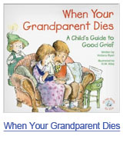 | When Your Grandparent Dies: This book addresses the needs of both children and the people who are their caregivers. Often the loss of a grandparent is the first experience a child has with grief. The ordeal is bewildering and painful. This book explains what will happen from the view of a child, depicting the days before and after, as well as beyond the death of a grandparent. The meanings of death along with heaven are explained, along with the ways that a child can remain close to the grandparent that died. It includes ideas and questions that help with discussion.
Helping a child to cope with death takes time. But when you have one of the above books to help, it will make it a lot easier.

