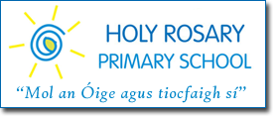

First Holy Communions this Saturday – we need your help!

Dear 1st Class Parents,
On Saturday, May 27th, many of the children from our 2nd classes will make their First Holy Communion, followed usually by a reception for the families in the school hall.
For many years it has been the custom for 1st class parents to help organise and run this reception. Hopefully you will enjoy the same goodwill next year for your child's First Communion.
This year there will be two Communion Services. If you can help out at either reception or setting up the hall on the previous day, Friday, please return the slip below or contact Kathleen H.S.C.L. on 086 0276666.
Thank you,
Kathleen McKiernan, H.S.C.L.
I can help out on:
Friday at 3.00pm
Saturday at 11.00am
Saturday at 12.30pm

Signed:

