Questions about death

What is death?
Death happens when someone’s body stops working. They no longer breathe, eat or drink. Their body goes cold and stays very still.

Why do people die?
Someone’s body might have been damaged by a bad accident or they might have had a very serious illness or disease that doctors couldn’t make better.

When do people die?
Most people die because they are very old and their body is worn out. But not everyone who dies is very old.

Is death forever?
Yes. When someone dies nothing can bring them back to life.

Questions about what happens after death
How you answer these types of questions will depend on your spiritual beliefs. It’s alright not to know all the answers, but try to be as honest as you can and face any difficult issues that your child wants to raise.

What happens after death?
No one knows for certain what happens after someone dies. Different people have different ideas and beliefs although many share some of the same ones.

Do people have a soul? What is a soul?
As well as a physical body, some people believe that we have a soul or spirit, which makes us who we are. They believe the soul is always there, even when our body is dead.

Where do you go when you die?
Some people believe that a person’s soul or spirit goes to heaven or somewhere similar like jannah or paradise. In heaven their body is free from pain and they are no longer ill. Other people believe that when you’re dead there is nothing more.

If (the person who died) is in heaven/jannah/paradise, why are they buried?
Their body, which is the physical part that doesn’t work anymore, is buried. It’s their soul that is in heaven.

Can (the person who died) see me from heaven/jannah/paradise?
Some people find it comforting to think (the person who died) is watching and looking after them from above.

Can I telephone heaven/jannah/paradise? Why can’t I put up an extra long ladder to heaven?
Heaven is not like places here on earth – you cannot phone it or go there.

Why did God/Allah/Jehovah let (the person who died) die?
This is a question that many grown-ups can’t answer either. People who believe in God believe that everything happens for a reason. This means there’s a bigger plan to everything that happens that only God knows about. This can be difficult for people to understand, especially when it’s so painful. Other people find it comforting.

Questions about funerals
If your child is going to the funeral talk to them about it beforehand, especially if they’ve never been to one before. This will give them an idea of what to expect. Be aware of how you explain cremation to children as they can find the idea of fire quite frightening.
For more suggestions, see Child Bereavement UK’s information about explaining funerals, burials and cremation to children .

What is a funeral?
Funerals are special ceremonies which give family and friends who cared about the person who died a chance to come together to remember them, to say goodbye and to celebrate their life. A funeral may be at a religious building such as a chapel, church, temple, synagogue or mosque. Sometimes they are at a place called a crematorium.

What happens at a funeral?
The body of the person who died is usually put in a special box called a coffin. Music is often played and people usually speak about the person who died. The body of the person who died may be buried in the ground. Sometimes instead of being buried people are cremated. This is when the body is turned into soft ashes.

What do people wear to funerals?
People sometimes wear black or dark clothes to go to a Christian funeral. However some people don’t like to do this. And sometimes the person who died may have said that they didn’t want people to wear dark clothes. In different cultures, different colours can be worn. For example, Hindus wear white to funerals.

Why do people dress up?
People dress up as a mark of respect to the person who has died.

How long does the funeral last?
There is no set time. It depends on how many hymns or songs there are and how many people speak.

Will people cry at the funeral?
Many people cry at funerals because they feel sad. However, there can also be happier moments when people remember the person who died and things they did together.

Can I go to the funeral?
(if you’re OK with them going) Of course you can go to the funeral but you don’t have to.

What happens after the funeral?
People sometimes like to put flowers on the coffin or donate money to a charity as a way of remembering the person who died. After this, people often eat and drink together, and talk about the person who has died as a way of celebrating their life.

What is cremation?
At the end of the funeral, some curtains will be drawn around the coffin and we will not see it again. After everyone has gone the coffin, with the body, is put into a special, very hot oven to be turned into ash. We do not watch this bit. The ashes are then put into a special pot called an urn. Some people scatter the ashes somewhere very special to the person who has died. Or they can be buried in the ground.

Will it hurt?
The person who died won’t know that they’re in a coffin or that they have been buried and if they are cremated it won’t hurt. That’s because after death their body cannot feel, hear or see.

Questions about the person who died
Not knowing what happened can make death more upsetting and frightening. There are no set answers to these questions. However, try to give as much detail as you think the child can cope with according to their age and level of understanding. Never underestimate their capacity to understand. Be guided by them and make it easy for them to ask whatever they need to.
Children may ask things like:
- What exactly happened when my Mum died?
- Did you see her die?
- Was she in pain?/Did it hurt?
- What did the doctor say?

Questions about how they'll be affected
Your child may be frightened that they are going to die too. Knowing why someone died may help to take away some of that fear. They may also think that if only they hadn’t been naughty or made so much noise, had helped more or loved the person more, they wouldn’t have died. They may have felt angry with the person who died and wished that they weren’t there or didn’t take up so much time.
It’s important for them to know that there is nothing they could have done to stop the person dying. It can help to concentrate on talking about good memories and happy experiences.

Will I die?
One day. We all die, usually when we're old. You won’t die just because someone you know has died.

Can I catch cancer?/Will I have a heart attack?/Could I die of (whatever the person died of)?
You can’t catch cancer or a heart attack. But some diseases are genetic – this means they can be passed down from parents to children. This is not always the case, however.

Was it my fault?
It’s not your fault that (the person who died) died. Being naughty doesn’t make someone die. And being kind and loving can’t stop someone from dying either – nor do wishes and thoughts. Everyone says and does things that later they wish they hadn’t.

Questions about who will take care of them
Again, there are no set answers. When a parent or other close family member dies there often are major changes. It’s best to be honest about these. Your child may not like what they hear but dealing with reality is better than dealing with a fantasy.
Most children prefer to have something concrete to deal with rather than to guess and worry about what might happen. It may be that the news is better than they expect.
If your child is afraid to go to school, contact their teacher. They might allow extra phone calls during the day so that the child feels more in control.

(If a parent died) – Will my Mum/Dad die too?
When a parent dies, children often fear that the other parent or carer will die too – especially if the other person becomes ill. Young children may believe that all illnesses have the same outcome and need to be reassured that most don’t end in death.

Will we have to move/change school/have enough money?
Your child may worry about how the family will manage financially or whether they will need to move house or school.

Questions about the future
It’s important that your child doesn’t feel that they’re betraying the person who has died by getting on with their life. It can help to find a special way to mark anniversaries, perhaps once a month at first and then every year. Your child might like to make a card or pick a flower to take to the place where the person has been laid to rest.

Will my sad feelings go away?
Sad feelings don’t last forever. If something reminds you of (person who died), you may feel sad again for a while.

Will I ever feel happy again?
People do feel happy again, although they never forget the person who died. It’s ok if you laugh and have fun.

Will I forget my Mum/Dad/person who died?
You will never forget the person who has died. As time goes by you’re likely to start to feel less upset than you do now and to find a way of giving the person who died a new place in your life and your memories.

Other questions children may ask
The following questions are also sometimes asked. You might like to think about these and other questions just in case a child brings them up.
- Will we still go on holiday?
- Will I still get pocket money?
- Who will help me with my homework?
- Can I go to the cemetery?
- Can I make a special card to take to the cemetery?
- Will we be together when I die?

Further support
Sometimes children need further support to cope with their grief. Signs to look out for include:
- changes in eating patterns
- low moods
- self-harming
- talking about wanting to be with their special person
- significant changes in behaviour and feeling angry

Explaining funerals, burial and cremation to children
It is easy for an adults to assume that a child will know what a funeral is and why we have them. In reality, few do, unless they have previously experienced the death of someone they know. Any information that they already have has probably come from the media or overheard, usually misunderstood, conversations.
When someone dies, most people gain some comfort from an opportunity to say goodbye at the Funeral. It is no different for children. As long as they have been prepared and given the choice to be there, or not, they find it a helpful experience.
You may have concerns about a Funeral being too “adult” a ritual. It may reassure you to know that none of the children and young people that we support at Child Bereavement UK, regretted choosing to attend.
A very young child, toddler, or even a baby can be there with the rest of the family. Although they will not understand at the time, it is when older that children appreciate knowing that along with everyone else they were a part of this important event.
If your children choose not to attend, or being there is not possible for them, remember that there are other alternatives. You could decide together to have a private family farewell or do something special to remember the person who has died.
Read more:
- Explaining Funerals Burial and Cremation
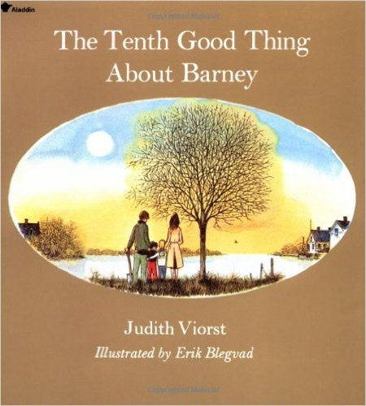

The Tenth Good Thing about Barney
Author: Judith Viorst
Judith Viorst has written and lovely and touching look at death from the perspective of a child. Though dealing with the death of a pet, it helps children deal with the reality of any death including why we have funerals. This book does not have religious overtones, so it can be used by families with all different sets of beliefs.
Buy from Amazon
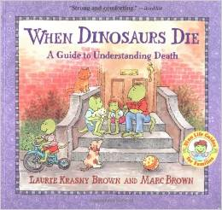

When Dinosaurs Die: A Guide to Understanding Death
Author: Laura Krasny Brown & Marc Brown
An excellent resource for children when they try to grasp the concept of death and understanding grieving; recommended for children who have faced, or are facing loss, but also for any child even before an urgent need presents itself. Includes chapters on “Why does someone die?” covering lots of eventualities.
Buy from Amazon
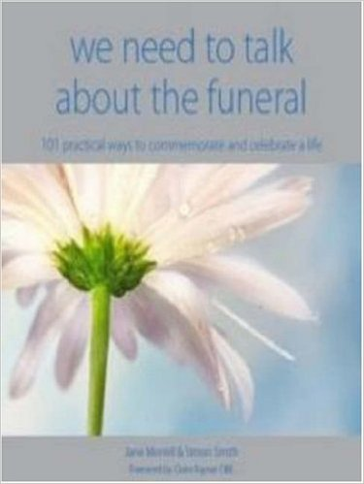

We Need to Talk About the Funeral: 101 Practical Ways to Commemorate and Celebrate Life
Author: Simon Smith and Jane Morell
This enlightening, beautiful and practical book informs about the wide choices available when arranging a funeral. It shows you how to make a funeral ceremony that both commemorates and celebrates a life, and provides comfort, inspiration and good memories.
Buy from Amazon
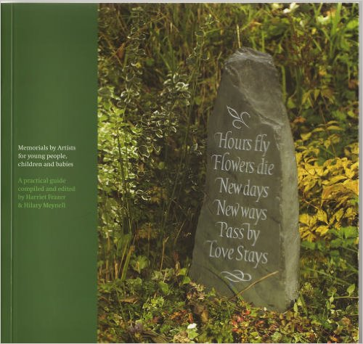

Memorials by Artists for Young People, Children and Babies
Author: Harriett Frazer
A guide to help families who are facing the extremely hard task of finding a memorial to celebrate the life of a young person, from birth to 30 years.
Buy from Amazon

Books for and about grieving children
Reading story books about death can help a child learn more and realise they’re not alone. We’ve also included a short reading list below. Some of these books are intended for adults, and some are for teens. A more detailed reading list for teenagers can be found here.
If you’re a child who’s recently lost someone close, please get in touch with one of the charities listed at the bottom of this page.
On this page:
Books for children
Books for adults
External websites
Healing children’s grief: surviving a parent’s death from cancer (2000) by Grace H Christ (Oxford University Inc. USA, £19.99)
This book will help adults better understand how children process grief. The author uses academic research methods to study the mourning process in different age groups, including their changing interactions with family and friends and their support needs.
Grief in children: a handbook for adults (1991) by Atle Dyregrov (Jessica Kingsley Publishers, UK, £12.95)
Similar to the previous book, this helps adults understand the different physical and psychological reactions in children when someone dies.
When someone has a very serious illness: children can learn to cope with loss and change (1991) by Marge Heegaard (Woodland Press, USA, £5.99)
A book that was created to help children understand the changes when someone in their family has a serious illness. Each section of text has a blank space underneath for children to illustrate and show their own feelings about what’s happened.
When someone very special dies: children can learn to cope with grief (1988) by Marge Heegaard (Woodland Press, USA, £5.99)
This book helps children come to terms with their grief by drawing what they’re feeling.
What Does Dead Mean?: A Book for Young Children to Help Explain Death and Dying (2012) by Caroline Jay and Jenni Thomas (Jessica Kingsley Publishers, UK, £9.99)
This book guides children through questions they often ask about death and dying. It’s suitable for children aged four and above and is an ideal book for parents and carers to read with their children. It’s also suitable for teachers, therapists and counsellors working with young children.
Gentle Willow: A Story for Children about Dying (2003) by Joyce C. Mills (Magination Press, USA, £8.95)
Written for children who may not survive their illness or for the children who know them, this tale helps address feelings of disbelief, anger, and sadness, along with love and compassion. Amanda and Little Tree discover that their friend Gentle Willow isn't feeling very well.
Michael Rosen’s Sad Book (2011) by Michael Rosen and Quentin Blake (Walker Books, UK, £5.99)
This chronicles Michael's grief at the death of his son Eddie from meningitis at the age of 19. A moving combination of sincerity and simplicity, it acknowledges that sadness is not always avoidable or reasonable and explains complicated feelings in simple terms.
Overcoming Loss by Julia Sorensen (2008) (Jessica Kingsley Publishers, UK, £19.99)
This book is full of creative and play-based activities to help children understand and come to terms with different emotions including shame, anger and jealousy.
Help Me Say Goodbye: Activities for Helping Kids Cope When a Special Person Dies (1999) by Janis Silverman (Fairview Press, USA, £8.99)
An art therapy and activity book for children coping with death. Sensitive exercises address all the questions children may have during this emotional and troubling crisis. Children are encouraged to express in pictures what they’re often incapable of expressing in words.
As big as it gets: supporting a child when a parent is seriously ill (1997) by Julie A. Stokes (Winston’s Wish, UK, £5.99)
Provides ideas for parents and carers so that they can involve their children in what is happening. The book also includes some suggestions about what parents might say to children and how to offer support.
Badger’s parting gifts (1984) by Susan Varley (Anderson Press, UK, £6.99)
Many families have found this book useful when helping children to come to terms with the death of someone close. It tells the story of Badger’s peaceful death and his friends remembering what Badger taught them while he was alive.
Never too young to know: death in children’s lives (1999) by Phyllis Silverman (Oxford University, Press Inc, USA, £16)
This book includes children’s stories of how they’ve coped with death, but is intended for an adult audience.
A child’s grief: supporting a child when someone in their family has died (2009) by Di Stubbs (Winston’s Wish, UK, £6.95)
This book covers a variety of issues that may affect a child when a person close to them dies, both immediately and in the longer term. It also has practical suggestions and ideas for activities to do together.
back to top

Books for adults
Healing children’s grief: surviving a parent’s death from cancer by Grace H Christ (2000) (Oxford University Inc. USA, £19.99)
This book will help adults better understand how children process grief. The author uses academic research methods to study the mourning process in different age groups, including their changing interactions with family and friends and their support needs.
Grief in children: a handbook for adults by Atle Dyregrov, (1991) (Jessica Kingsley Publishers, UK, £12.95)
Similar to the previous book, this helps adults understand the different physical and psychological reactions in children when someone dies.
Never too young to know: death in children’s lives by Phyllis Silverman (1999) (Oxford University, Press Inc, USA, £16)
Silverman’s book includes children’s stories of how they’ve coped with death, but is intended for an adult audience.

